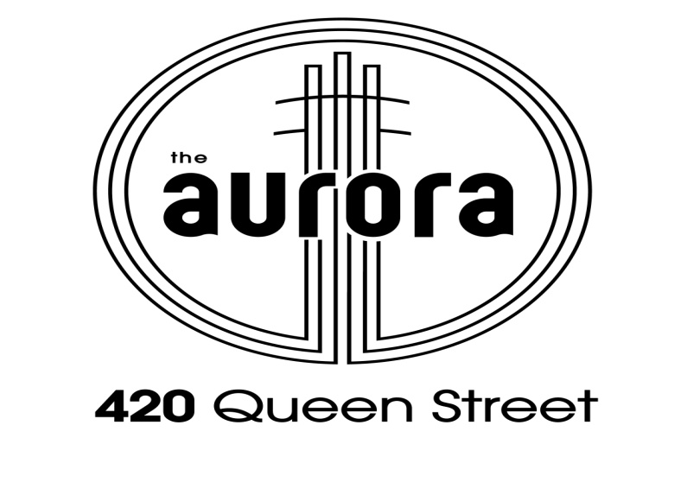
AIR CONDITIONING SYSTEM TEMPORARY SHUT DOWN FOR REPAIRS

5th to 21st October

Attention – EVERYONE (2nd notice) !

The Aurora Tower Body Corporate has approved for major repairs to the building’s Air Conditioning (AC) system. Works are scheduled for 29th September to 21st October.

The Air Conditioning system will be shut down from 5th to 21st October.

During the shut down your AC will not be operational – do not use your AC.

Please ensure your Air-Conditioner is switched OFF during this period as there will be no cooling water.

BUILDING MANAGEMENT - FOR AND ON BEHALF OF BODY CORPORATE CTS 35222

